Capgemini Big Data and Azure Engineering Batch

Database Fundamentals and TSQL programming

Day 3:

Assignments

- Write SQL query to INSERT DATA to a table with IDENTITY(1,1) COLUMN?
- Write SQL Query to find the ListPrice in range of 150 to 250 from this table. Select only 10 records.

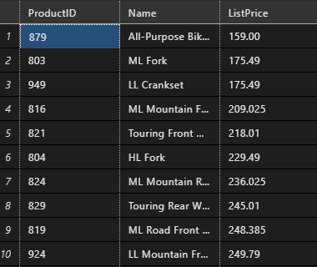

- Write SQL query to find the list of Customers from Customer table with these specific CustomerID

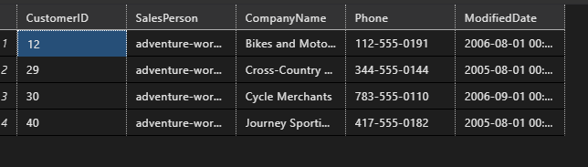

- Student_reg_A
Reg_no | Name | % obtained
210101 | Harry | 80
210102 | Harry | 70
210103 | Chris | 84
210104 | Lee | 85

Write SQL query to retrieve the % Marks obtained from the distinct students.

- Write a SQL query to add CHECK constraints in the following table so that only positive values of “ListPrice” and “ProductCost” fields can be added for the Product Table.

ProductID | ProductName | ProductCost | ListPrice
001 | Bikes | 20.00 | 18.99
002 | Cycles | 16.50 | 12.64

